AI ASSISTED CODING
NAME: N. Chandhana Priya
BATCH: 39
ROLL NO: 2303A52342

Lab 8: Test-Driven Development with AI – Generating and
Working with Test Cases

Task Description #1 (Password Strength Validator – Apply AI in
Security Context)
• Task: Apply AI to generate at least 3 assert test cases for
is_strong_password(password) and implement the validator
function.
• Requirements:
o Password must have at least 8 characters.
o Must include uppercase, lowercase, digit, and special
character.
o Must not contain spaces.
Example Assert Test Cases:
assert is_strong_password("Abcd@123") == True
assert is_strong_password("abcd123") == False
assert is_strong_password("ABCD@1234") == True
Expected Output #1:
• Password validation logic passing all AI-generated test cases.
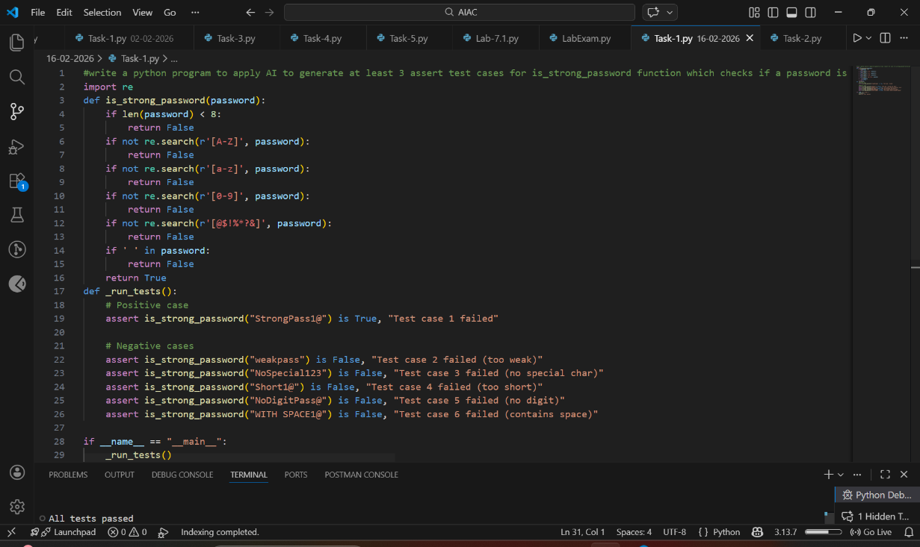

ANALYSIS:
- The prompt clearly defines all security rules:
- Minimum 8 characters
- Uppercase, lowercase, digit, special character
- No spaces

Task Description #2 (Number Classification with Loops – Apply
AI for Edge Case Handling)
• Task: Use AI to generate at least 3 assert test cases for a
classify_number(n) function. Implement using loops.
• Requirements:
o Classify numbers as Positive, Negative, or Zero.
o Handle invalid inputs like strings and None.
o Include boundary conditions (-1, 0, 1).
Example Assert Test Cases:
assert classify_number(10) == "Positive"
assert classify_number(-5) == "Negative"
assert classify_number(0) == "Zero"
Expected Output #2:
• Classification logic passing all assert tests.
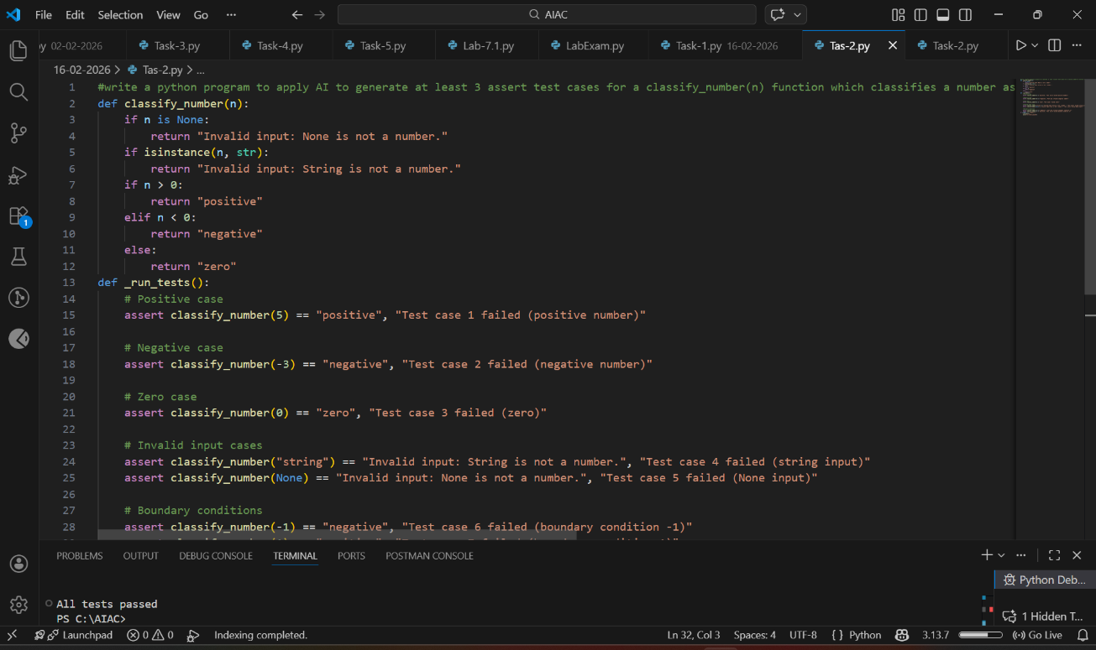

ANAYLISIS:
- The task clearly states:
- Classify numbers as Positive, Negative, or Zero
- Handle invalid inputs (like string and None)
- Include boundary values (-1, 0, 1)

Task Description #3 (Anagram Checker – Apply AI for String
Analysis)
• Task: Use AI to generate at least 3 assert test cases for
is_anagram(str1, str2) and implement the function.
• Requirements:
o Ignore case, spaces, and punctuation.
o Handle edge cases (empty strings, identical words).
Example Assert Test Cases:
assert is_anagram("listen", "silent") == True
assert is_anagram("hello", "world") == False
assert is_anagram("Dormitory", "Dirty Room") == True
Expected Output #3:
• Function correctly identifying anagrams and passing all AI-
generated tests.
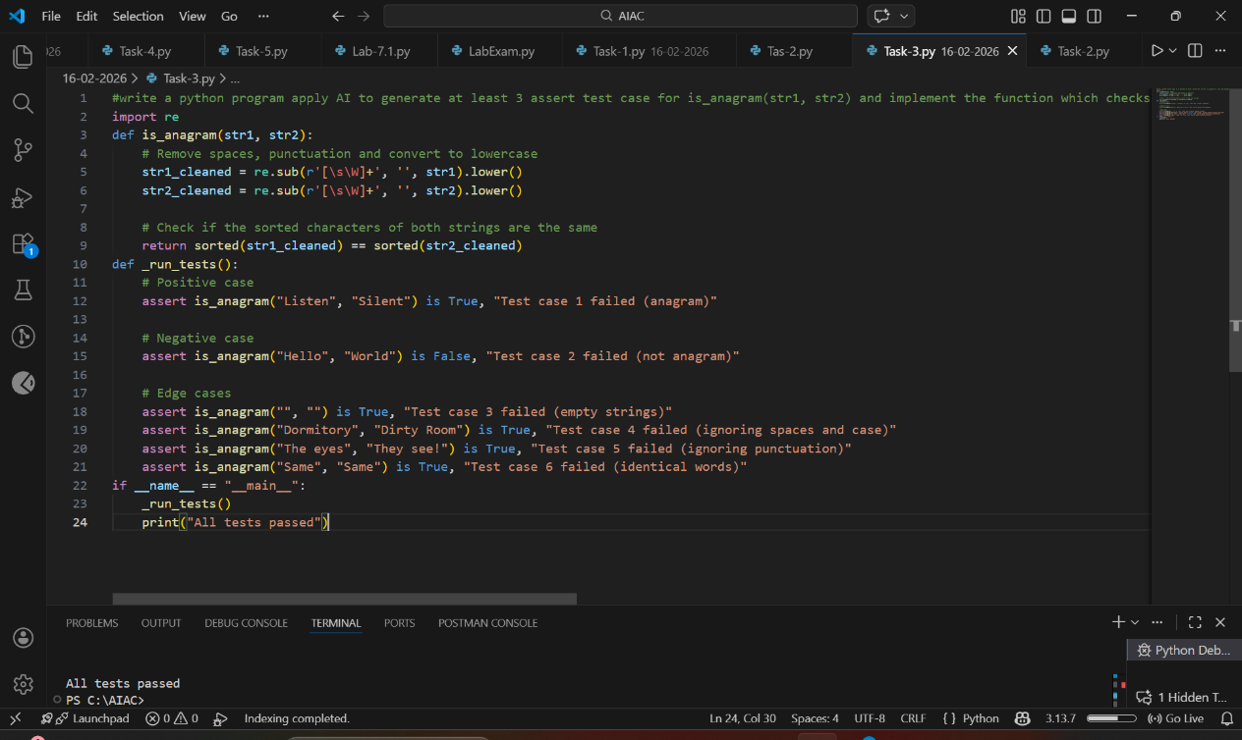

ANALYSIS:
- The requirements are clear: ignore case, spaces, and punctuation.
- This makes the function practical and realistic, not just basic string comparison.
- Handling empty strings and identical words improves reliability.
- It ensures the function works in all boundary situations.

Task Description #4 (Inventory Class – Apply AI to Simulate Real-
World Inventory System)
• Task: Ask AI to generate at least 3 assert-based tests for an
Inventory class with stock management.
• Methods:
o add_item(name, quantity)
o remove_item(name, quantity)
o get_stock(name)
Example Assert Test Cases:
inv = Inventory()
inv.add_item("Pen", 10)
assert inv.get_stock("Pen") == 10
inv.remove_item("Pen", 5)
assert inv.get_stock("Pen") == 5
inv.add_item("Book", 3)
assert inv.get_stock("Book") == 3
Expected Output #4:
• Fully functional class passing all assertions.
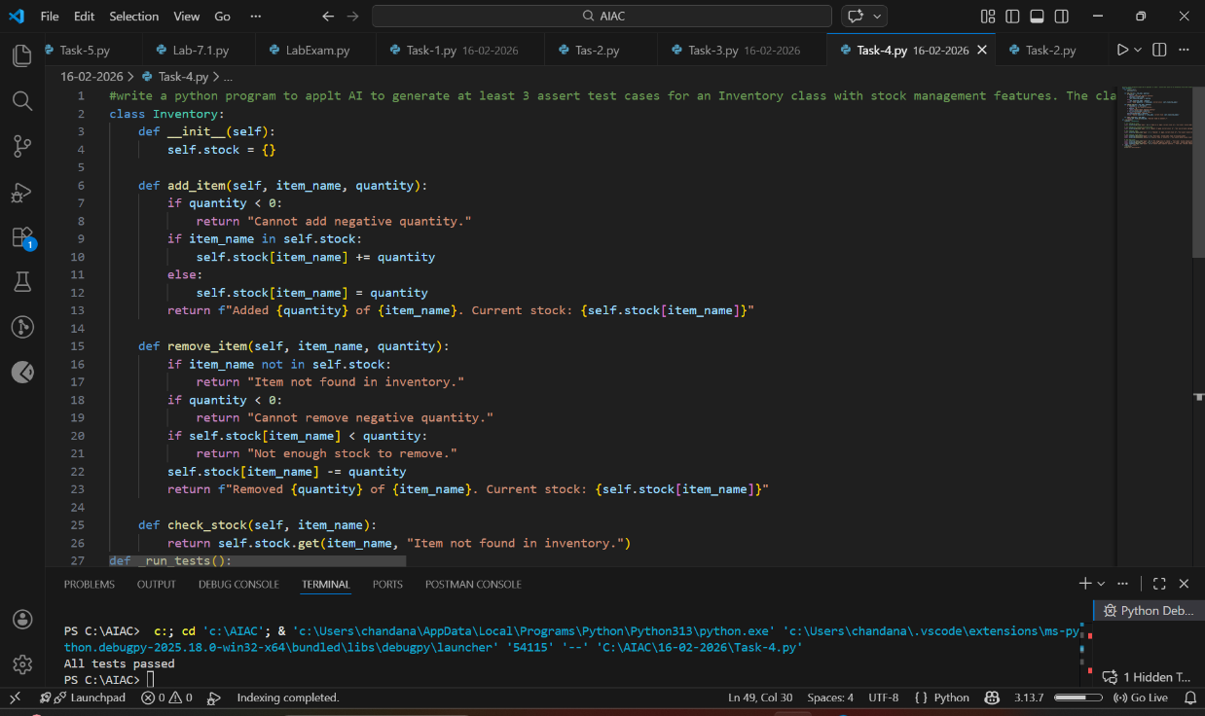

ANALYSIS:
- This task simulates a real inventory system (like a shop or warehouse).
- It is more practical compared to simple functions.
- It improves understanding of object-oriented programming (OOP).
- Using a class with methods (add_item, remove_item, get_stock) promotes modular design.
- It teaches how to manage data properly inside objects instead of using global variables.

Task Description #5 (Date Validation & Formatting – Apply AI for
Data Validation)
• Task: Use AI to generate at least 3 assert test cases for
validate_and_format_date(date_str) to check and convert
dates.
• Requirements:
o Validate "MM/DD/YYYY" format.
o Handle invalid dates.
o Convert valid dates to "YYYY-MM-DD".
Example Assert Test Cases:
assert validate_and_format_date("10/15/2023") == "2023-10-15"
assert validate_and_format_date("02/30/2023") == "Invalid Date"
assert validate_and_format_date("01/01/2024") == "2024-01-01"
Expected Output #5:
• Function passes all AI-generated assertions and handles edge
cases.
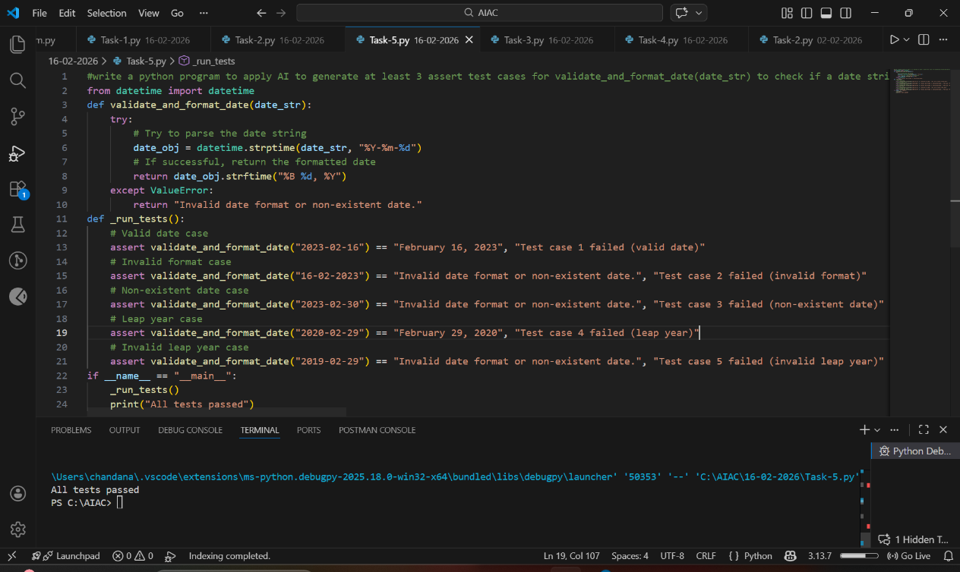

ANALYSIS:
- Unlike simple string tasks, this requires:
- Checking correct format structure
- Verifying month range (1–12)
- Verifying valid days per month
- Handling leap years (e.g., Feb 29)
- The prompt includes invalid dates like "02/30/2023", which tests logical validation, not just string formatting.
- This ensures the function is logically correct, not superficially correct

